Aaniin gakina wiiya, 3/1/25

Onaabani-giizis (March) is here! This month’s shout out comes from one of our parents. We would like to highlight Ms. Heidi Schultz and Ms. Cassidy Anderson. These gals will greet you with a warm smile and welcoming vibes! Miigwech for all the love and snuggles you provide for our babies! Stay tuned for a very special surprise on KOJB! ❤️

“A little shout-out to Teacher Cassidy and Teacher Heidi in Gidagaakoons for their dedication to exposing our children to the Ojibwe language. I see their effort and how much it means to them to pass the language on to the next generations. I’ve had the privilege of seeing them work on words, phrases, and songs with the babies in their care when I visit my own. Even my older kids have started picking up words and phrases just from hearing them during drop-off and pick-up. Their hard work is truly making a difference – miigwech for all that you do!”

– Alyssa Finn, proud parent ❤️

If you have any questions about the phrases/song of the month, feel free to email me < [yodi.blomgren@llojibwe.net](mailto:yodi.blomgren@llojibwe.net) > or stop by for a visit < first cubicle to the left when you enter the 2nd door >. I am free to visit classrooms, just let me know what works for your daily schedules. Weweni go ~ Yodi

Aabawaamagad agwajiing.

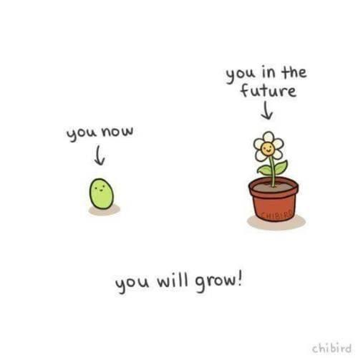*It is warm outside.*

Gidoo-zhiitaa na?

*Are you ready?*

Ozhiitaadaa!

*Let’s get ready!*

Giziibiigininjiin song

March Language Survey

Classroom: ______________________ Date _________

Staff: _________________________

Please discuss at your *weekly staff meeting* the following phrases and song. Record how often you used each phrase, when did you incorporate the phrases/song in your day(s), what resources did you send home for families, and how did it go. **Kindly return to Yodi by 3/21/25**

1. Aabawaamagad agwajiing: *\*visuals/translations in this packet*

__________________________________________

__________________________________________

__________________________________________

1. Gidoo-zhiitaa na?

__________________________________________

__________________________________________

__________________________________________

1. Ozhiitaadaa:

__________________________________________

__________________________________________

__________________________________________

1. Giziibiigininjiin song:

__________________________________________

__________________________________________